**Project Planning Phase**

**Project Planning (Product Backlog, Sprint Planning, Stories, Story points)**

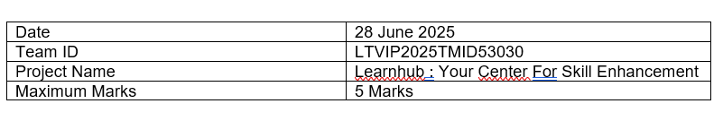

**Product Backlog, Sprint Schedule, and Estimation (4 Marks) :**

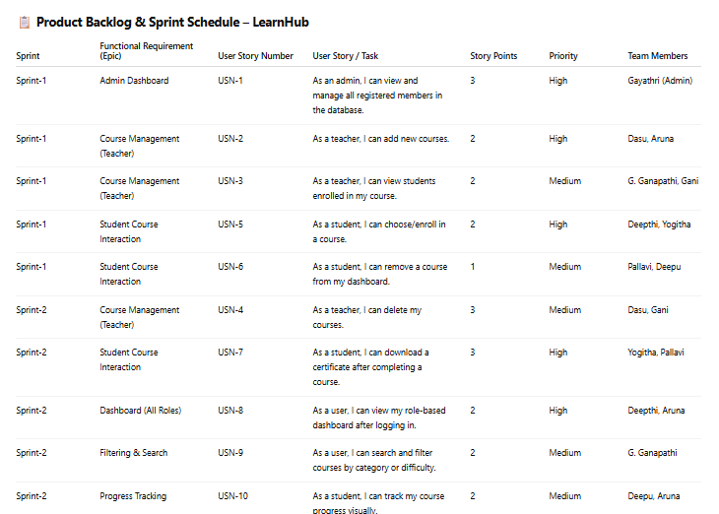

**Sprint Story Point Summary:**

* Sprint 1 Total: 10 Story Points
* Sprint 2 Total: 12 Story Points
* Estimated Team Velocity: ~11 story points/sprint

**Project Tracker, Velocity & Burndown Chart: (4 Marks)**

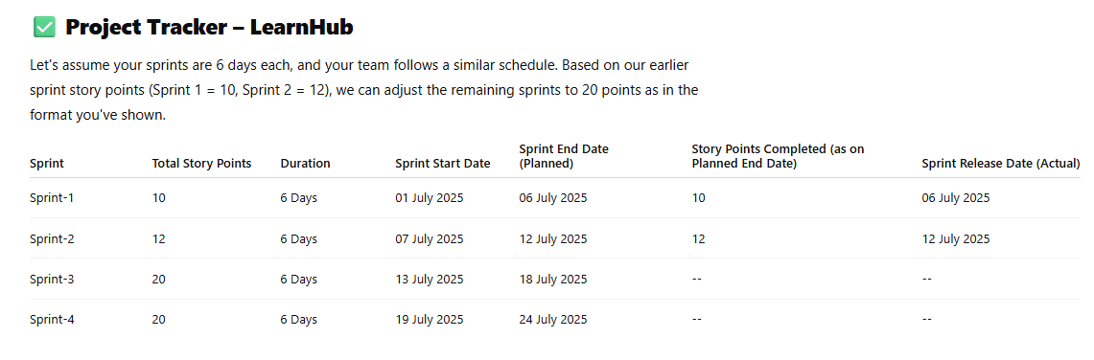

**Velocity Calculation**

**Velocity** = Total Story Points Completed / Number of Sprints Completed  
= (10 + 12) / 2 = **11 Story Points per Sprint**

Now, to calculate **Average Velocity per Day** (for Burndown Chart):

* Each sprint = 6 days
* Total completed = 22 points over 12 days
* So, **Average Velocity = 22 ÷ 12 = 1.83 story points per day**